Lab 2.3.3.4 Configuring a Switch Management Address

Topology

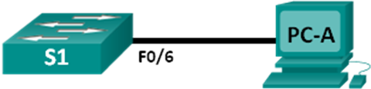

1. Addressing Table

|  |  |  |  |
| --- | --- | --- | --- |
| Device | Interface | IP Address | Subnet Mask |
| S1 | VLAN 1 | 192.168.1.2 | 255.255.255.0 |
| PC-A | NIC | 192.168.1.10 | 255.255.255.0 |

1. Objectives

Part 1: Configure a Basic Network Device

Part 2: Verify and Test Network Connectivity

1. Background / Scenario

Cisco switches have a special interface, known as a switch virtual interface (SVI). The SVI can be configured with an IP address, commonly referred to as the management address. The management address is used for remote access to the switch to display or configure settings.

In this lab, you will build a simple network using Ethernet LAN cabling and access a Cisco switch using the console and remote access methods. You will configure basic switch settings, IP addressing, and demonstrate the use of a management IP address for remote switch management. The topology consists of one switch and one host using only Ethernet and console ports.

1. Configure a Basic Network Device
   1. Configure basic switch settings.

In this step, you will configure basic switch settings, such as hostname, and configure an IP address for the SVI. Assigning an IP address on the switch is only the first step. As the network administrator, you must specify how the switch will be managed. Telnet and SSH are two of the most common management methods. However, Telnet is a very insecure protocol. All information flowing between the two devices is sent in plaintext. Passwords and other sensitive information can be easily viewed if captured by a packet sniffer.

Enter global configuration mode to set the SVI IP address to allow remote switch management.

S1# **config t**

S1#(config)# **interface vlan 1**

S1(config-if)# **ip address 192.168.1.2 255.255.255.0**

S1(config-if)# **no shut**

S1(config-if)# **exit**

S1(config)#

Configure the VTY line for the switch to allow Telnet access. If you do not configure a VTY password, you will not be able to telnet to the switch.

S1(config)# **line vty 0 4**

S1(config-line)# **password cisco**

S1(config-line)# **login**

S1(config-line)# **end**

S1#

* 1. Configure an IP address on PC-A.

Assign the IP address and subnet mask to the PC, as shown in the Addressing Table.

1. Verify and Test Network Connectivity

You will now verify and document the switch configuration, test end-to-end connectivity between PC-A and S1, and test the remote management capability of the switch.

* 1. Display the S1 device configuration.

Return to your console connection using **Hyperterminal** on PC-A. Issue the **show run** command to display and verify your switch configuration. A sample configuration is shown below. The settings you configured are highlighted in yellow. The other configuration settings are IOS defaults.

S1# **show run**

Building configuration...

Current configuration : 1508 bytes

!

! Last configuration change at 00:06:11 UTC Mon Mar 1 1993

!

version 15.0

no service pad

service timestamps debug datetime msec

service timestamps log datetime msec

no service password-encryption

!

hostname S1

!

boot-start-marker

boot-end-marker

!

enable secret 4 06YFDUHH61wAE/kLkDq9BGho1QM5EnRtoyr8cHAUg.2

!

no aaa new-model

system mtu routing 1500

!

!

no ip domain-lookup

!

spanning-tree mode pvst

spanning-tree extend system-id

!

vlan internal allocation policy ascending

!

!

interface FastEthernet0/1

!

interface FastEthernet0/2

<output omitted>

interface FastEthernet0/24

!

interface GigabitEthernet0/1

!

interface GigabitEthernet0/2

!

interface Vlan1

ip address 192.168.1.2 255.255.255.0

!

ip http server

ip http secure-server

!

banner motd ^C

Unauthorized access is strictly prohibited. ^C

!

line con 0

password cisco

login

line vty 0 4

password cisco

login

line vty 5 15

login

!

end

Verify the status of your SVI management interface. Your VLAN 1 interface should be up/up and have an IP address assigned. Notice that switch port **F0/6** is also up because PC-A is connected to it. Because all switch ports are initially in VLAN 1, by default, you can communicate with the switch using the IP address you configured for VLAN 1.

S1# **show ip interface brief**

Interface IP-Address OK? Method Status Protocol

Vlan1 192.168.1.2 YES manual up up

FastEthernet0/1 unassigned YES unset down down

FastEthernet0/2 unassigned YES unset down down

FastEthernet0/3 unassigned YES unset down down

FastEthernet0/4 unassigned YES unset down down

FastEthernet0/5 unassigned YES unset down down

FastEthernet0/6 unassigned YES unset up up

FastEthernet0/7 unassigned YES unset down down

FastEthernet0/8 unassigned YES unset down down

FastEthernet0/9 unassigned YES unset down down

FastEthernet0/10 unassigned YES unset down down

FastEthernet0/11 unassigned YES unset down down

FastEthernet0/12 unassigned YES unset down down

FastEthernet0/13 unassigned YES unset down down

FastEthernet0/14 unassigned YES unset down down

FastEthernet0/15 unassigned YES unset down down

FastEthernet0/16 unassigned YES unset down down

FastEthernet0/17 unassigned YES unset down down

FastEthernet0/18 unassigned YES unset down down

FastEthernet0/19 unassigned YES unset down down

FastEthernet0/20 unassigned YES unset down down

FastEthernet0/21 unassigned YES unset down down

FastEthernet0/22 unassigned YES unset down down

FastEthernet0/23 unassigned YES unset down down

FastEthernet0/24 unassigned YES unset down down

GigabitEthernet0/1 unassigned YES unset down down

GigabitEthernet0/2 unassigned YES unset down down

* 1. Test end-to-end connectivity.

Open a command prompt window (cmd.exe) on PC-A by clicking the **Windows Start** icon and entering **cmd** into the **Search for programs and files** field. Verify the IP address of PC-A by using the **ipconfig /all** command. This command displays the PC hostname and the IPv4 address information. Ping PC-A’s address and the management address of S1.

Ping the PC-A address first.

C:\Users\NetAcad> **ping 192.168.1.10**

Your output should be similar to the following screen:

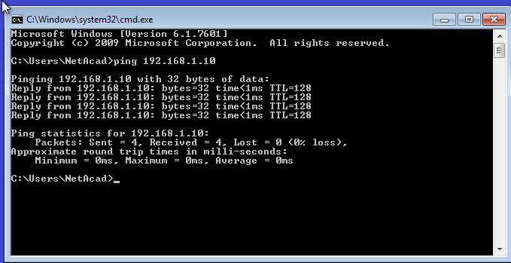

Ping the SVI management address of **S1**.

C:\Users\NetAcad> **ping 192.168.1.2**

Your output should be similar to the following screen. If ping results are not successful, troubleshoot the basic device configurations. You should check both the physical cabling and IP addressing if necessary.

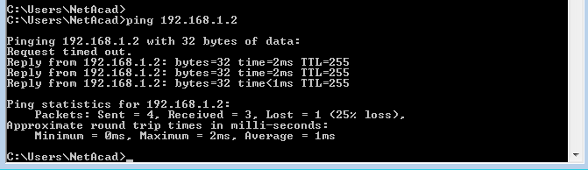

* 1. Test and verify the remote management of S1.

You will now use Telnet to remotely access the switch S1 using the SVI management address. In this lab, PC-A and S1 reside side by side. In a production network, the switch could be in a wiring closet on the top floor while your management PC is located on the ground floor. Telnet is not a secure protocol. However, you will use it in this lab to test remote access. All information sent by Telnet, including passwords and commands, is sent across the session in plaintext. In subsequent labs, you will use SSH to remotely access network devices.

With the command prompt window still open on PC-A, issue a Telnet command to connect to S1 via the SVI management address. The password is **cisco**.

C:\Users\NetAcad> **telnet 192.168.1.2**

Your output should be similar to the following screen:

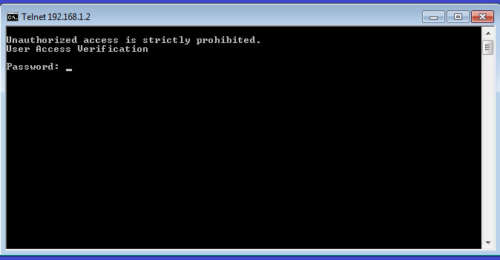

After entering the **cisco** password, you will be at the user EXEC mode prompt. Type **enable** at the prompt. Enter the **class** password to enter privileged EXEC mode and issue a **show run** command.

* 1. Save the configuration file.

From your Telnet session, issue the **copy run start** command at the prompt.

S1# **copy run start**

Destination filename [startup-config]? **[Enter]**

Building configuration ..

S1#

* 1. Erase the startup configuration file.

Use the **erase startup-config** command to erase the startup configuration file from NVRAM. When you are prompted to remove the configuration file, press Enter to confirm the erase. (Pressing any other key will abort the operation.)

S1# **erase startup-config**

Erasing the nvram filesystem will remove all configuration files! Continue? [confirm]

[OK]

Erase of nvram: complete

S1#

* 1. Reload the switch.

Reload the switch to remove any old configuration information from memory. When you are prompted to reload the switch, press Enter to proceed with the reload. (Pressing any other key will abort the reload.)

S1# **reload**

Proceed with reload? [confirm]

**Note**: You may receive a prompt to save the running configuration prior to reloading the switch. Type **no** and press Enter.

System configuration has been modified. Save? [yes/no]: **no**

Exit the Telnet session by typing **quit**. You will be returned to the Windows command prompt.